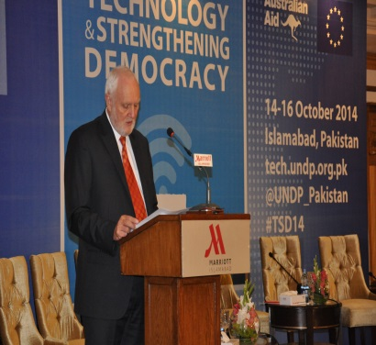
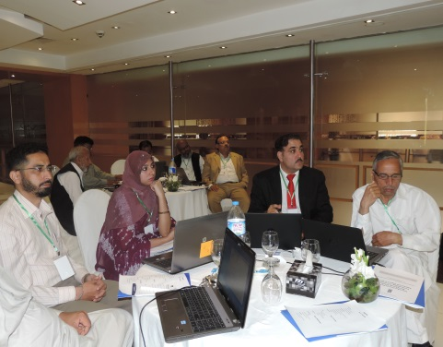
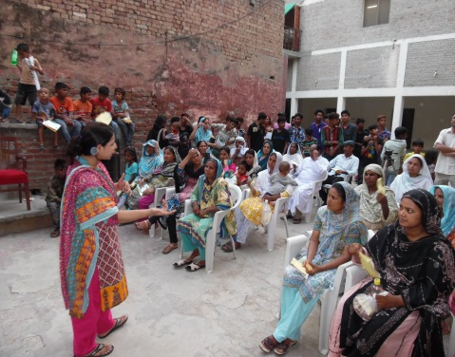
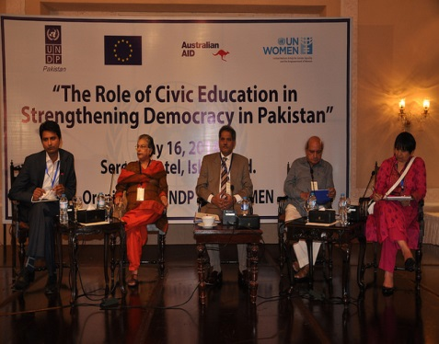
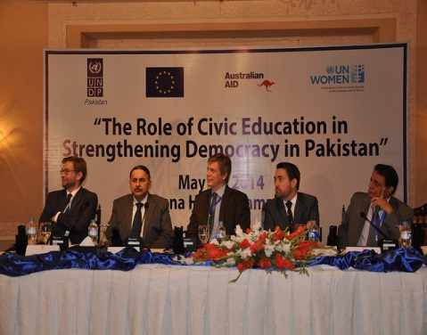
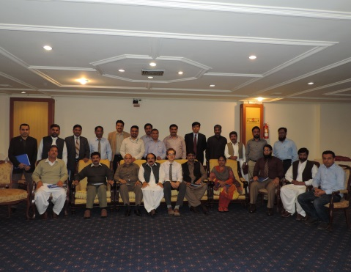
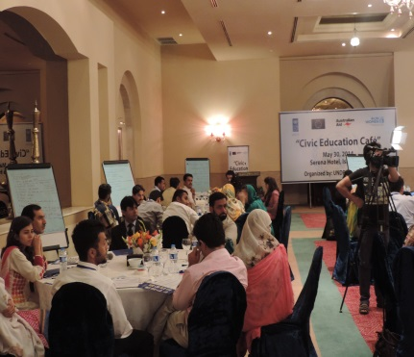
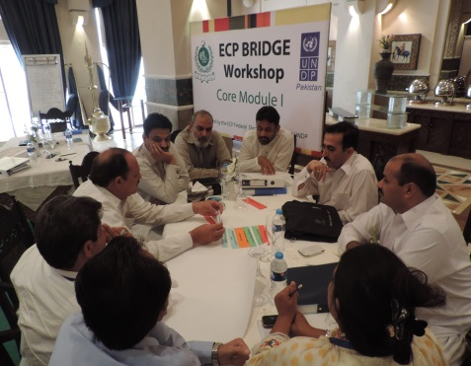
Electoral Cycle Support to the Election Commission of Pakistan
Annual Progress Report

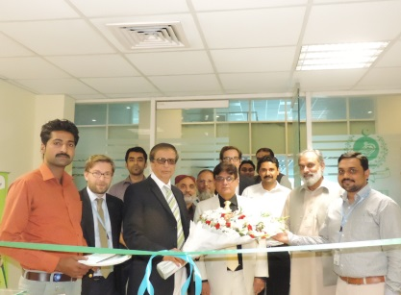
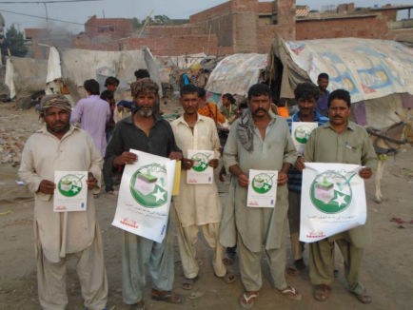
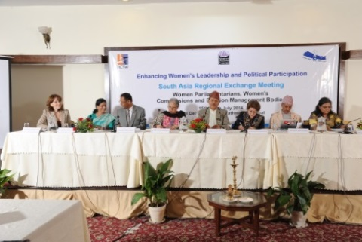
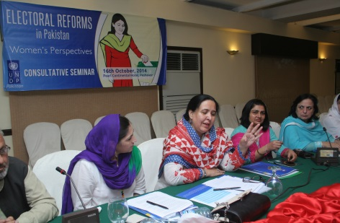

2014

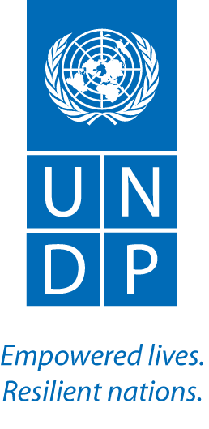

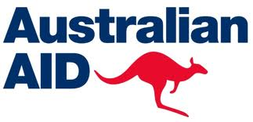
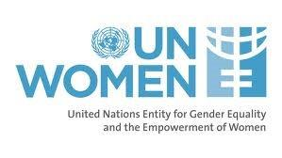

PROJECT SNAPSHOT
Date |  | 01/12/2015
Award ID |  | 00062980
Project ID |  | 0081893
Project Title |  | Electoral Cycle Support to the Election Commission of Pakistan
Project Start Date |  | January 2012
Project End Date |  | December 2017
Implementing Partners |  | ECP and UN WOMEN
Project Brief Description and Outputs:
The focus of the project is on the provision of technical assistance and operational support to the Election Commission of Pakistan (ECP). Strategically, the project takes an “electoral cycle” approach to assistance, providing support pre-elections, during elections, and post-elections. The project is divided into two phases – Phase I: Pre-elections and the (General) Elections and Phase II: Post-elections. In Phase I (January 2012 – July 2013) the project’s core focus was on providing operational support and technical assistance to the ECP for the May 2013 General Elections. Phase II, (July 2013 – 31 December 2017), is focused on leveraging the post-election period to a) address the challenges identified during Phase I b) transform the results from Phase I into sustainable outcomes and c) structure programming interventions around core post-election tasks such as developing the operational and administrative capacity of the ECP at the national, provincial and district levels in accordance with its new 5-Year Strategic Plan (2014-2018), implementing advocacy initiatives to build public and political pressure for electoral reforms, and conducting comprehensive civic and voter education campaigns, primarily targeting women and youth. These tasks were informed by a comprehensive assessment of the post-election environment and subsequently shaped the design of the project outputs.
Output 1 ECP’s internal governance standards, operational performance and public outreach are improved.
Output 2 Multiple stakeholders are engaged in dialogue and agree on key electoral reforms.
Output 3 Citizens and select government departments are engaged in civic and voter education activities.

Budget 2014 | $3,503,229
Expenditure by end of the year | $2,820,510
Delivery % | 81%

Acronyms
AWP | Annual Workplan
ANP | Awami National Party
AJK | Azad Jammu and Kashmir
BRIDGE | Building Resources in Democracy, Governance and Elections
CSO | Civil Society Organization
CEC | Chief Election Commissioner
CVE | Civic and Voter Education
DEC | District Election Commissioner
ECP | Election Commission of Pakistan
EO | Election Officer
EU | European Union
EDR | Election Dispute Resolution
EMB | Election Management Body
FEA | Federal Election Academy
GIS | Geographical Information System
IFES | International Foundation for Electoral Systems
KPK | Khyber Pakhtunkhwa
LFC | Legal Framework Committee
MQM | Muttahida Qaumi Movement
NCSW | National Commission on the Status of Women
NWM | National Women’s Machinery
OTT | Office Technology Training
PEC | Provincial Election Commissioner
PRB | Project Review Board
PPP | Pakistan People’s Party
PTI | Pakistan Tehreek-e-Insaaf
RO | Returning Officer
SAARC | South Asian Association for Regional Cooperation
SGIB | SAARC Gender Info. Base
TNA | Training Need Assessment

Table of Contents

 | Executive Summary | 05
1. | Introduction | 07
2. | Situation Analysis | 07
3. | Project Performance | 09
4. | Lesson Learnt | 27
5. | The Way Ahead/Key Priorities for 2015 | 28
Annex 1: | AWP Based Reporting Matrix

Executive Summary
The uncertainty over local government elections during the first quarter, and the Election Commission’s suspension of a significant proportion of programing activities between August and October as a consequence of the PTI and PAT led protests, prevented the project from achieving all the activities and targets detailed in the Annual Work Plan (AWP). For example, the training of ECP officials on civic education, training courses on management and leadership for senior ECP officials, and the development of a strategic communications plan were pushed back to the first quarter of 2015. These factors notwithstanding, the majority of targets in the AWP were accomplished, generating results during the course of the year which have not only enhanced the professional skills of ECP officials and developed the ECP’s in-house training capacity, but also catalyzed initiatives to address one of the defining features of Pakistan’s democratic deficit: the estimated 11 million women who are not registered to vote.
To elaborate, highlights included: a BRIDGE training for ECP officials at the district level on boundary delimitation ahead of the local government elections; civic and voter education initiatives which reached over 30,000 women and youth in districts with low levels of voter turnout and voter registration (one pilot initiative in Punjab, conducted in collaboration with NADRA and a local civic society organization, led to women actively applying for CNIC cards); the inclusion in the ECP’s new Strategic Plan of a specific goal on women empowerment and gender equality; the establishment of the ECP’s Federal Election Academy, supported by a comprehensive training strategy; provincial seminars on electoral reforms involving women, youth, civil society, the media and academia; and a conference on The Role of Technology in Strengthening Democracy which helped to inform the debate among electoral stakeholders on the merits and demerits of electoral technologies, such as Electronic Voting Machines (EVMs). The matrix below provides a quantitative insight into the achievements that occurred.
ACTIVITIES | NUMBER OF  PARTICIPANTS
Office Technology Training for Elections Management | 184
BRIDGE Training | 199
CVE Seminars | 189
Technology Conference | 600
Election Reform Seminars | 287
Micro Capital Grants to CSOs – Training of Master Trainers | 62
Hiring of local UNVs for CVE Activities | 25
Street Theatre Promoting CVE Among Women & Youth | 50,014

An encouraging sign during the course of the year has been the ECP’s determination to leverage outside technical assistance to enhance its operational capacity and improve its administration of electoral processes. Progress was made prior to the 2013 General Election and the ECP, despite its shortcomings, does appear to be genuinely committed to building on the progress that has been made. This was illustrated by the development in 2014 of its second 5-Year Strategic Plan, a process that was informed by the technical assistance provided by UNDP and IFES, and a process which underlined the ECP’s candid recognition of what needs to be done in order strengthen the integrity of electoral processes in Pakistan and ensure they are aligned with international standards.
The new Strategic Plan, a training needs assessment and lessons learned from the 2013 General Election provide an overarching framework to guide external technical assistance and sequence priorities over the next four years. This is why UNDP’s core focus during 2014 has been centered on getting the basics right, i.e. developing and strengthening the knowledge and technical skills of ECP officials, especially at the district level – the critical interface between the general public and the ECP. A two year, thematically linked training curriculum has been developed for District Election Commissioners and Election Officers, the design of which has been collaborative to ensure a sense of ownership and relevance. The first phase of the trainings have been completed through the Office Technology Trainings and the design and implementation of a customized BRIDGE module (covering electoral laws and boundary delimitation).
By using the BRIDGE methodology the intent is to build the ECP’s capacity (through having its own cadre of accredited BRIDGE trainers) to conduct its own trainings and diminish the need to outsource. The establishment of the Federal Election Academy, inaugurated in October 2014 and funded by UNDP for the next two years, provides the operational infrastructure to build in-house training capacity. By the time of the next elections (presuming they are not in 2015) the ECP should be able to conduct a significant portion of trainings in-house (without external technical assistance or financial support), especially the training of polling officials and regular refresher courses on electoral management issues for ECP officials.
Building the capacity of the ECP to improve its administration of electoral processes will not be sufficient on its own to bolster public perceptions about the integrity, and legitimacy, of the electoral system in Pakistan. This requires a broader, holistic, approach – a factor that is reflected in the project’s objectives which also focus on electoral reform and civic and voter education initiatives to increase turnout among women and youth. Regarding electoral reforms, UNDP, along with IFES, provided technical assistance to the ECP’s Legal Framework Committee, helping it to draft a unified electoral reform bill. The Bill was submitted to the Special Parliamentary Committee for Electoral Reforms in October 2014, when media interest in this topic was at its peak following the PTI led protests.
Electoral reform, however, is primarily a political process led by parliament. As such the project developed a political strategy to complement its technical assistance, leveraging in-house political contacts and expertise to help shape the political dialogue on electoral reforms and nurture the development of a robust political consensus on a comprehensive reform process. On-going, informal dialogues have been, and continue to be, held with all members of the parliamentary committee. An informal dinner with senior officials from all the major parties was co-hosted by the EU Ambassador and the UNDP Country Director (a follow up dinner is scheduled for February 2015) while a series of provincial dialogues were held with a range of electoral stakeholders which will culminate in the presentation of a report to the parliamentary committee in February 2015.
Addressing low voter turnout among women, diminishing the number of unregistered women voters and nurturing democratic mindsets among youth represent the defining features of the civic and voter education initiatives conducted by the project during 2014, and subsequent activities planned for 2015, 2016 and 2017. Districts with low levels of women turnout have been identified through the RMS database that was developed through the scanning of polling station results forms after the 2013 General Election. The design of programming initiatives on civic and voter education has been informed by data generated by a nationwide survey of 5,000 people conducted by the project in June/July 2014. Further modifications will be made following assessments of lessons learned from four pilot projects that were completed in December 2014.
The pilots involved providing micro credit grants to a civil society organization (CSO) in each province (selected through a competitive bid process) to design and implement customized (i.e. sensitive to specific cultural dimensions in a given area) civic education initiatives in targeted districts. Project staff trained Master Trainers at each CSO and assisted with the design of civic education strategies. The intent is to not only generate self-generating initiatives at the community level, but also to develop the skills and capacity of local CSOs to conduct effective civic and voter education initiatives. In addition, 25 local United Nations Volunteers have been selected from five universities (one from each province) to conduct civic education initiatives on campus and in rural communities over the next 6 months. If the project is successful it will be expanded to other universities.
Finally, a comprehensive civic and voter education plan was developed in collaboration with the ECP PR Department and formally approved by the Members and Acting CEC. Implementation will begin during the first quarter of 2015, focusing on training District Election Commissioners to establish district committees on civic and voter education in collaboration with local CSOs and elected officials. The combined intent of all the various civic and voter education initiatives being implemented by the project is to support broader efforts to promote active citizen engagement and increase voter turnout among women and youth.
In summary, the project is on course to accomplish its objectives and secure the desired long term impact of establishing an electoral system in Pakistan that is anchored in a legal framework consistent with international standards, characterized by an inclusive democratic culture, and administered by an electoral management body equipped with the necessary technical skills, operational capacity and public trust to effectively discharge its constitutional mandate.

- Introduction

The UNDP Electoral Cycle Support to the Election Commission of Pakistan (ECP) Project provides operational and technical assistance to the ECP to hold credible, transparent and inclusive elections. The project was established in January 2012 following a request for electoral assistance by the ECP to the United Nations, and in accordance with the recommendations of a UN Electoral Needs Assessment Mission to Pakistan. The project is governed by a Project Review Board (PRB) comprising donors, the ECP and UNDP. The project’s annual work plans are submitted to the PRB every December for approval.

Operationally, the project works closely with the ECP to ensure that all activities are aligned with the ECP’s Strategic Plan and sequence of priorities. The project monitors its activities through a comprehensive performance monitoring and data collection framework. Evaluation of the impact of activities is conducted through questionnaires, data comparison where applicable, and impact surveys. The project is partnering with UN Women to promote gender mainstreaming across all activities and the project coordinates, and where appropriate, collaborates with other organizations offering electoral assistance, and participates regularly in information-sharing fora such as monthly meetings of the Electoral Support Group (ESG).

Strategically, the project takes an “electoral cycle” approach to assistance, providing support pre-elections, during elections, and post-elections. The project is divided into two phases – Phase I: Pre-elections and the (General) Elections and Phase II: Post-elections.

In Phase I (January 2012 – July 2013) the project’s core focus was on providing operational support and technical assistance to the ECP for the May 2013 General Elections. The project contribution during this phase included: training 330,665 polling staff using improved and practical training methods and materials; developing an elections results management system for faster and more transparent compilation of elections results; developing and producing voter education materials; supporting a national media and social media voter education campaign to encourage higher voter turnout among women, men, first-time voters, minorities and the disabled; advising the ECP on developing a methodology for collecting gender-disaggregated voter turnout; and training 17,152 police in electoral security.

Phase II, (July 2013 - ), is focused on leveraging the post-election period to a) address the challenges identified during Phase I b) transform the results from Phase I into sustainable outcomes and c) structure programming interventions around core post-election tasks such as developing the operational and administrative capacity of the ECP at the national, provincial and district levels in accordance with its new 5-Year Strategic Plan (2014 – 2018), implementing advocacy initiatives to build public and political pressure for electoral reforms, and conducting comprehensive civic education campaigns to nurture democratic mindsets among Pakistan’s burgeoning youth population. These tasks were informed by a comprehensive assessment of the post-election environment and subsequently shaped the design of the project outputs for Phase II. The primary focus during 2014 was to establish the programmatic foundations for achieving these objectives over the next four years.

Specifically the project focused on five main areas of support during 2014:
- Assisting the ECP to adjust to the post-election period and prioritize core tasks relating to institutional development.
- Establishing the Federal Election Training Academy
- Developing the technical skills of ECP officials (primarily those at Grades 17 & 18)
- Initiating civic and voter education programmes to be scaled up during 2015, 2016 and 2017
- Shaping the debate among all electoral stakeholders on the issue of electoral reform

- Situation Analysis
The operational environment during 2014 has been punctuated by periods of uncertainty and political crisis, both of which delayed the implementation of activities designed to support the ECP’s institutional development. The first quarter was marked by uncertainty over whether the local government elections would take place in KP, Sindh and Punjab. Following the official announcement in early March that the elections would be delayed until at least 2015 the ECP announced that it would spend the next two months developing a new 5-Year Strategic Plan. As a consequence, the implementation of all activities detailed in the project’s AWP were held in abeyance until the completion of the ECP’s new Strategic Plan in late April. Further delays occurred in August and September as a consequence of the PTI and PAT protests and the subsequent need for the ECP to focus its efforts on preparing for a possible judicial inquiry into the 2013 General Elections. Given the gravity of the situation it is not surprising that the ECP regarded institutional development priorities of secondary importance to the immediate need of responding to media and political allegations of malpractice.
The political crisis exposed the negative institutional impact of not having a permanent Chief Election Commissioner. This factor, combined with the imminent retirement of the Secretary and the absence of the Additional Secretary (who was away for 5 months on a mandatory civil service training course), meant that the ECP was deprived of authoritative leadership at a critical time. The ECP would have been able to navigate the troubled political waters more effectively if it had taken steps to established regular consultative forums with political parties, civil society and other key stakeholders. The political crisis and the attacks by opposition parties, particularly PTI, against the ECP, underlined the critical need for the ECP to build relations with political parties and ensure regular dialogue. Absent this relationship and the ECP will continue to suffer the diminution in public trust which is an inevitable consequence of persist attacks by politicians and the media.
Moving forward the ECP needs to make stakeholder management a fundamental priority, especially if a comprehensive package of electoral reforms are passed during 2015. The development and implementation of a Strategic Communications Plan to structure engagement with all electoral stakeholders would help the ECP to foster a more nuanced and favourable narrative about its institutional performance. The appointment of a new, permanent, CEC in December and likelihood of a new Secretary being appointed during the first quarter of 2015 offer the ECP an opportunity to ‘reset’ relations with political parties and project a new image to broader electorate.
It is critical to emphasize, however, that while some organizational weaknesses were exposed during the drawn out street protests from August to October, it is important not to overlook the significance of positive developments that offer hope that the ECP can achieve its institutional potential. Firstly, within the ECP there is a strong ‘culture of learning’, as evidenced by the requests for technical trainings using the BRIDGE methodology. Secondly, senior management recognize that the ECP’s institutional posture will be enhanced when it can demonstrate in-house capacity to effectively carry out the full range of electoral administration tasks. Thirdly, the new Strategic Plan is a candid recognition of what needs to be achieved in order to ensure the ECP has the capacity to improve the integrity of electoral processes and ensure future elections are held according to international standards. This honest assessment of the current reality enables external assistance providers such as UNDP and IFES to engage constructively with the ECP and be guided by a clear set of institutional development priorities. This is not always the case with EMBs in other countries.
Another factor that is often overlooked is the talent that exists within the ECP’s ranks, especially at the district level. There are a number of officials at the Grade 17 and 18 levels who have demonstrated immense potential to acquire technical knowledge and skills. Their advancement through the ranks bodes well for the future.
If there has been one positive from the recent political turmoil it has been the emergence of electoral reform as a public policy priority. It is now firmly on the political radar as a consequence of the protests that took place and the subsequent media interest. The challenge now is to ensure that the current political momentum for reform does not dissipate. A major focus of the project during the early part of 2015 will be to step up political engagement and identify ways to maintain public pressure for electoral reform in order to influence the political calculus of the ruling party.
Regarding civic and voter education, especially among women and youth, the current environment offers fertile ground to expand programming in this area. Data from the nationwide survey combined with qualitative insights from the civil society pilot projects and a series of seminars with women, youth and civil society underline the demand for basic information on rights, responsibilities and how to actively engage in the democratic process. This will be pursued by working with a cross-section of key stakeholders: the ECP, Women’s Parliamentary Caucuses at the Federal and Provincial level, the National Commission on the Status of Women, political parties, the media, civil society and Higher Education Councils in each province.

- Project Performance

KEY RESULTS ACHIEVED DURING THE REPORTING PERIOD
  - Progress towards Project Results/Outputs

Project Output I:
ECP’s internal governance standards, operational performance and public outreach are improved
Indicator(s):  - No. of customized core BRIDGE Modules Developed  - No. of ECP BRIDGE Facilitators Accredited  - No. of staff trained through BRIDGE and technical workshops |  | Baseline:  - ECP does not have any core BRIDGE modules, and has been using generic international training models  - No systematic implementation of  BRIDGE  Modules |  | Target(s):  - 2 customized core Modules  - 20 training workshops conducted for ECP staff |  | Achievement(s):  The target was not fully achieved due to the suspension of programing activities following the PTI protests (August to October). As a consequence 15 trainings were held (OTT and BRIDGE).  A series of 8 OTT trainings were conducted. A total of 184 ECP officials – DECs and EOs were trained on Office Technology Training (OTT) in the four provinces of Pakistan.  Men Women Total  182 02 184  7 BRIDGE trainings were conducted. 199 District Election Officers (DECs) including facilitators were trained on BRIDGE training from the four provinces of Pakistan.  Men Women Total  195 04 199
Description of output level results achieved in 2014:
The sustainability of any institution is conditioned by its legal status, its assets and services, the quality of its staff and the financial resources it has at its disposal. During 2014, UNDP’s technical and operational support to the ECP was focused on the assets, services and staff components of institutional sustainability. The following results were achieved under output-1:

  - Gender Mainstreaming and the Development of the ECP New 5-Year Strategic Plan
UNDP provided technical expertise throughout the two month period (March/April) during which the new Strategic Plan was developed.
Additionally, UNDP in collaboration with UNWOMEN, worked with the ECP’s Gender Committee to develop a specific Strategic Goal (with supporting objectives) for Gender Mainstreaming. UNDP provided regular technical assistance and, through its intervention, persuaded the ECP Secretary to include a Strategic Goal on gender mainstreaming in the Strategic Plan (he initially wanted to have a separate Strategic Plan for gender, undermining the very principle of gender mainstreaming). . The inclusion of this Strategic Goal was a major achievement as it commits the ECP to implement a wide-range of gender mainstreaming activities over the next 5 years.

  - Establishment of Federal Election Academy (FEA)
After being mooted for 7 years the ECP’s FEA has finally been established through the support of UNDP. To structure the activities of the FEA, UNDP conducted a Training Needs Assessment (TNA) which involved interviews with 95 ECP officials from across the country. Based on the TNA, a comprehensive training plan was developed and approved by the ECP in February, 2014. The training plan was designed to improve the knowledge and technical skills of these officials and covers a range of thematic areas from electoral technology and election laws to civic and voter education.

BRIDGE Curriculum Development Workshop

“This is the first time we have seen our partners come with an exit strategy.” – ECP Official
Electoral administrators and international organizations worldwide have used the award-winning BRIDGE capacity development program since 2001. UNDP believe that the program has the potential to have a transformative effect on the work and culture of the ECP, but only if the mode of implementation changes dramatically with greater ownership and leadership by the ECP officers. UNDP’s experience from over a decade of BRIDGE implementation globally shows that BRIDGE is most effective when it is implemented by an Election Management Body (EMB) with a comprehensive strategy to customize the curriculum, and systematically develop facilitation capacity within the staff of the implementing organization.
The BRIDGE training program was used as a professional capacity development tool that has enhanced individuals’ skills and knowledge. It has also contributed in improving the overall administrative functioning of the ECP as an intuition. UNDP has worked with the ECP to help them develop and implement a series of customized module workshops (core modules) closely aligned to the jobs and interests of the ECP officials, as well as a systematic plan for facilitator development and accreditation.
UNDP held BRIDGE curriculum development workshops in the month of February. The workshop was attended by ECP BRIDGE facilitators and led by UNDP’s Expert BRIDGE facilitator. The core work of this team was to customize the BRIDGE training modules in the context of ECP’s laws, systems, procedures and approaches. The group reviewed key understandings from the facilitator training course, technicalities of the curriculum, and the needs assessment of district level officers. The group developed a comprehensive curriculum framework covering the three core modules and the initial curriculum for the first module.
The core group met again from 8-9 May, 2014 as well as 10-15 June, 2014 to finalize the core modules. Three training sections were developed during the meetings - Legal Framework, Boundaries Delimitation and Personality Development. During the workshop training modules, training topics, agenda, methodology, facilitators’ notes, power point presentations and participants hand outs were developed and shared among the working group and their inputs were incorporated. This approach was deeply appreciated by the ECP.
  - BRIDGE Training on Core Module-1 and Delimitation:
In October 2014 the Election Commission of Pakistan (ECP) asked UNDP to train the District Election Commissioners (DEC’s) and the Election Officers (EO’s) in Boundary Delimitation for the Local Government Elections.
The BRIDGE curriculum which was developed by the facilitator team earlier in the year already consisted of the module on Delimitation of Constituencies. This module was designed to target the front-line staff of the ECP at the district, divisional, provincial and national level. Therefore it was decided to conduct these trainings under the BRIDGE umbrella which is not only a tried and tested training methodology but also gives accrediting opportunities to the facilitators within the ECP. The main aim of UNDP is to build capacity of the ECP to conduct its own trainings.
Two workshops were held in Lahore from 24th November – 5th December 2014 and two were held in Karachi from 8th December – 19th December 2014.
The workshop was facilitated by the expert facilitator with the help of BRIDGE accredited facilitators from the ECP. The mode of language was both Urdu and English.
During the initial introduction most of the participants candidly admitted that they did not have any experience of the delimitation process. Consequently, the initial part of the training focused on generating awareness and understanding of international delimitation standards: contiguity & compactness, boundaries of administrative units, public convenience and communication, homogeneity, equal population (Equality), and other cognate factors. Additionally they learned about the natural boundaries that exist in the delimitation process, and were tasked to identify the wards, circles and blocks within the maps which were given to them for the delimitation process. Furthermore, they were introduced to concepts such as administrative units, revenue units, census units etc
The final two days of the trainings were focused on practical work with each person tasked with applying the knowledge that he had acquired by conducting delimitation of wards in their respective constituencies using the rural and urban maps.
Quotes from the Participants:

1. “The practical work on delimitation was great and I have learnt so much. First when I came I thought we will not be able to do it but now I am confident that I can do a great job.” (Imran Ahmed, District Election Commissioner, Jamshoro ECP)
2. “The conduct of delimitation workshops is a right step of UNDP, at the right time in the right direction, and with the right team at the helm of affairs.” (Asif Ali Yasin, PS to AS ECP)

1.5. Training Series: Office Technology Training (OTT)
The ECP has made progress in the use of electoral technology but information management across the institution is weak, and much of this is due to a weak understanding of computers and poor unitization of basic tools such as email and spreadsheets. A 2013 training needs assessment, conducted following the General Elections, identified technology training for mid-level officers as one of the key needs for capacity development in 2014-2017.
Therefore, UNDP offered the ECP a series of Office Technology Trainings (a total of 184 ECP officials; 2 women and 182 men – DECs and EOs - were trained). The course covered the management of data, file management, and data security as well as professional applications for email – this was not a generic course on MS office applications – but a highly specialized one with examples and exercises taken directly from the day to day work of electoral managers. The trainers for the course were UNDP’s technology team.
The course series was robustly evaluated with pre and post testing, daily session-by-session evaluation, and post-course knowledge retention evaluation. Participants were certified upon demonstration of competence upon successful passage of the post-test given in exam conditions.

The table below shows the series of Office Technology Trainings (OTT) conducted throughout the year.
S. No | Location | Dates | Participants | Status
1 | Islamabad | March 24-26, 2014 | 22 | Completed
2 | Multan | April 15-17, 2014 | 20 | Completed
3 | Lahore | April 28-30, 2014 | 24 | Completed
4 | Lahore | May 05-07, 2014 | 26 | Completed
5 | Karachi | May 21-23, 2014 | 24 | Completed
6 | Karachi | May 26-28, 2014 | 22 | Completed
7 | Quetta | August 6-8, 2014 | 28 | Completed
8 | Peshawar | June 24-26, 2014 | 18 | Completed
 |  | Total | 184

Quotes from the participants attended the Office Technology Trainings:
I1. “My children have a computer and a laptop at home and I was always afraid of using them. Now with the help of this training I will be using these computers and laptop to learn more so that I can do my office work efficiently.” Mr. Syed Akram DEC, Thatha).
- “My friend has a computer shop in Quetta, he often asks me to buy a laptop but I always reply that ‘I cannot use a computer.’ After receiving this training I have called him and ordered a laptop as now I am confident that I can operate computer.” Mr. Saif Din (DEC, Dera Bugti).

1.6 UNDP Conference -The Role of Technology in Strengthening Democracy: Opportunities and Challenges
In October the project hosted a three-day conference on ‘The Role of Technology in Strengthening Democracy: Opportunities and Challenges. Over 600 people attended the conference. The conference provided a discursive forum for key actors in the democratic process in Pakistan to discuss the role of technology in strengthening democracy with international practitioners and representatives from Pakistan’s growing technology sector.
The sessions over the three days brought together experts from a range of sectors highlighting the innovative work of Pakistan’s established and emerging leaders in civic sector and e-governance technologies. The sessions on the second day explored how technology is enhancing the integrity of electoral processes. There was also a session on the concept of e-parliament and how ICTs can help parliaments improve their performance across three core functions: law making, oversight and representation. The final day focused on how technology is changing the way civil society engages as digital observers, civic educators, and social actors.
Of particular importance during this three-day event were discussions on the role technology can play in reaching out to marginalized constituencies, such as women and youth, and the type of applications that will be effective in this regard, especially in areas with high levels of illiteracy. This was a recurrent theme informing discussions during each session. Of equal significance was the emphasis on the limitation of technology with regards to strengthening governance and how it needs to be seen as tool rather than a panacea for Pakistan’s governance challenges.
Key Outcomes:
• Increased awareness among ECP officials on how modern technology can promote more inclusive and responsive democratic institutions in Pakistan.
• Through case studies from other countries, there was increased recognition among electoral stakeholders that increasing citizen engagement through the use of ICTs can help to strengthen institutional legitimacy and diminish corrosive negative perceptions.
• A more nuanced understanding among electoral stakeholders, particularly the ECP, on the merits and demerits of electoral technologies such as biometric voter identification and electronic voting machines.
• A deeper knowledge among electoral stakeholders about the gradual changes in information consumption habits of youth and the implications this will continue to have on how election management bodies, civil society, political parties etc communicate with this audience.
Overall Output Status (mark the output on the scale of 1 to 5 as per the following criteria):
Exemplary (5)  ***** | High (4)  **** |  | Satisfactory (3)  *** |  | Poor (2)  ** |  | Inadequate (1)  *
The project is expected to over-achieve targeted outputs and/or expected levels of quality, and there is evidence that outputs are contributing to targeted outcomes | The project is expected to over-achieve targeted outputs and/or expected levels of quality |  | The project is expected to achieve targeted outputs with expected levels of quality |  | The project is expected to partially achieve targeted outputs, with less than expected levels of quality |  | Project outputs will likely not be achieved and/or are not likely to be effective in supporting the achievement of targeted outcomes
Means of Verification
Training Need Assessment Reports
FEA Building
Pre-Post Test
Approved Curriculums (BRIDGE, OTT and GIS)
Brief Training Reports shared with the ECP

Project Output II:
Multiple stakeholders are engaged in dialogue and agree on key electoral reforms
Indicator(s):  - No. of seminars/roundtables conducted on electoral reforms.  - No. of electoral reforms agreed upon and drafted by key stakeholders. |  | Baseline:  No electoral reforms passed  through Parliament in 2012-13  due to lack of interest among  political leaders in Electoral  Reforms. |  | Target(s):  - Hold at least 5 seminars/roundtables on electoral reforms at the national level and at least 8 at the provincial level. |  | Achievement(s):  On electoral reform workshops the project exceeded its target.  A total of 36 seminars were held. 287 people participated in the electoral reforms from all the four provinces of Pakistan  Men Women Youth Total  94 104 89 287
Description of output level results achieved in 2014:
The following results were achieved under output-2:
2.1. Nationwide Opinion Survey
A public opinion survey was conducted to probe on attitudes towards standards of democratic governance in Pakistan. The survey consisted of a nationally representative sample of 5,000 people across the country. The themes of the survey were: electoral reform, electoral processes, civic and voter education and the broader democratic process. The purpose of the survey was to generate data to shape the design of civic and voter education programing and inform the discussions at the provincial dialogue seminars on electoral reform.
2.2. Technical Support to the ECP’s Legal Framework Committee (LFC)
Following the delay in the holding local government elections, the ECP decided to use the time available to sharpen its focus on reforms to the legal framework for elections, informed by the lessons learned exercise conducted after elections with support from UNDP and IFES. The first meeting of the Legal Framework Committee (LFC) was held in February with both UNDP and IFES providing staff members to assist with the analysis of the existing legal framework and to provide technical advice on the reforms that need to be made. The LFC met on monthly basis during the year.
UNDP prepared a research note on “Disciplinary Jurisdiction” of the Election Commission of India over Officials Deputed for Election Duty. The note was shared with members of the ECP Legal Framework Committee (LFC). The Legal Framework Committee reviewed electoral laws and worked on drafting a unified election law. The note was prepared on the request of the ECP as a case study. The Legal Framework Committee also considered proposals to amend the existing electoral laws to enhance ECP disciplinary control over the staff deputed for election duties.
UNDP also assisted the sub-committee of the LFC in reviewing the existing provisions of the electoral laws on postal ballets, voting procedures, consolidation and the declaration of election results.
2.3. Working Paper - A year since the General Elections 2013; Discussion on Electoral Reforms
UNDP has completed a draft working paper on “A year since the General Elections 2013; Discussion on Electoral Reforms”. The working paper aimed to initiate multi-party debate on electoral reforms. The draft paper outlined proposed methodology of holding cross-party discussions on electoral issues.
2.4. UNDP Seminars on Electoral Reforms
To generate and maintain momentum for electoral reforms and inform the broader political debate, UNDP conducted 26 provincial dialogue seminars with women, youth, civil society, academia and the media. A report capturing the key issues raised will be submitted to the Special Parliamentary Committee for Electoral Reform in February. The intent of the report is to influence the political calculus of committee members by demonstrating the breadth of support for electoral reforms.

2.5. Implementing Gender-Sensitive Policies and Practices
In May, UNDP (under the auspices of the elections project) and UNWOMEN launched a series of seminars in partnership with the Women’s Parliamentary Caucus for “enhancing women’s participation in politics”. Two seminars were held with parliamentarians including the Speaker of National Assembly, the Chairpersons of Parliamentary Affairs Committees in National Assembly and Senate as well as other key representatives from government, CSOs, international partners and academia. More than 100 parliamentarians attended these seminars and reinforced the need to include more women in decision making within parliamentary and political party structures. A joint cross-party resolution was passed to advocate for legislation making it mandatory for all parties to allocate 10% of tickets for winnable seats to women.
The Speaker of the National Assembly, the Chairperson of the National Commission on the Status of Women (NCSW) and the Chairperson of the Women Parliamentary Caucus endorsed this resolution and requested the parliamentarians to propose strong measures and mechanisms for legislative reforms. In a smaller round table discussion the parliamentarians deliberated upon two “Private Members Bills” designed to address legal gaps that undermine women’s ability to fully engage in the democratic process. A roundtable was also held in collaboration with the National Commission on the Status of Women (NCSW) engaging the National Women’s Machinery from across the country including Azad Jammu and Kashmir (AJK). The participants were briefed on the series of seminars being held, they reviewed their provincial/state policies on women’s empowerment to ensure that these elements were reflected in this process.
In addition it was also agreed that there is a need for National Framework Guidelines on Women’s Empowerment which would provide the umbrella guidelines to the provinces.

  - UNDP Dialogue in Support of Women’s Political Participation and Leadership
In July, the project arranged a South Asia Regional Exchange meeting in Nepal from 15th -17th July, 2014, to effectively promote women’s leadership and political participation at all levels. 53 delegates participated in the meeting from Pakistan, Afghanistan, Bangladesh, Bhutan, India, Maldives, Nepal, and Sri Lanka.
The important sessions of the meeting were:
1) Mechanisms to enhance women’s political participation by looking at the status of women’s political participation in South Asia; Key initiatives for gender mainstreaming in Election Management Bodies; Women’s Participation and Leadership in Political Parties.
2) Challenges and opportunities for National Women’s Machinery (NWM) to have a more meaningful role.
3) Possible legal and institutional provisions to end violence against women and girls.

Some of the important recommendations proposed in the meeting:
- Build a common vision for the empowerment of women of South Asia for promotion of gender equality in social, political and economic fields;
- Raise a collective voice for at least 33% representation of women in all elected bodies (national and sub-national legislature and local governments) and in decision making levels of all institutions within political parties
- Advocating for a conducive and secure environment for women to contest elections, to exercise their right to vote and to administer elections as representatives of election management bodies.
- Within the SAARC development fund create a special fund for combating and preventing violence against women and develop standardized indicators for measuring the extent of violence against women at the second phase of SAARC Gender Info. Base (SGIB) for comparable data across the region.
- Advocate for the establishment of women caucuses and national commissions in all South Asian countries working towards setting up the Regional Network of Women Caucuses and Regional Women Commissions and a regional network of women’s machinery.
Overall Output Status (mark the output on the scale of 1 to 5 as per the following criteria):
Exemplary (5)  ***** | High (4)  **** |  | Satisfactory (3)  *** |  | Poor (2)  ** |  | Inadequate (1)  *
The project is expected to over-achieve targeted outputs and/or expected levels of quality, and there is evidence that outputs are contributing to targeted outcomes | The project is expected to over-achieve targeted outputs and/or expected levels of quality |  | The project is expected to achieve targeted outputs with expected levels of quality |  | The project is expected to partially achieve targeted outputs, with less than expected levels of quality |  | Project outputs will likely not be achieved and/or are not likely to be effective in supporting the achievement of targeted outcomes
Means of Verification
Working papers on Electoral Reforms
News on Electoral Reforms
News on SAARC meeting
UN Women Report

Project Output III:
Citizens and select government departments are engaged in civic and voter education activities
Indicator(s):  - Percentage of the activities in the ECP’s CVE Plan 2014 that are Implemented.  - No. of citizens (male, female, youth and minorities) reached through CVE activities |  | Baseline:  0% - CVE Plan 2014 to be drafted  and implemented in 2014  • An estimated 40 million people  reached under Phase 1 of the  Project |  | Target(s):  - At least 70% of the activities in the ECP’s CVE Plan are implemented through the year  - At least an additional 500,000 citizens to be reached in 2014 (including at least 100,000 men, 190,000 women, 100,000 male youth, 100,000 female youth and 10,000 minorities) by end of 2014. |  | Achievement(s):  189 People participated in the seminars on civic and voter education including civil society organizations, media and youth  Men Women Total  111 78 189  Micro Capital Grant was awarded to 4 CSOs, one in each province for a pilot project on civic education with local communities. A total of 62 master trainers of the CSOs were trained through interactive training techniques.  Men Women Total  35 27 62  25 UNVs selected to promote civic and voter education in schools and communities  Men Women Total  18 07 25  450 street theaters conducted in 32 districts of Pakistan covered the 50014 direct audience  Men Women Youth Total  19829 10086 20099 50014
Description of output level results achieved in 2014:
Although key targets were not met, significant achievements were nonetheless achieved, laying the basis or further progress in 2015, during which the ECP will being implementation of its civic and voter education plan.
For civic education programing to achieve desired psychological, sociological and political effects, it needs to be comprehensive, understood as a long term exercise, anchored at the grassroots, and innovative. The evolution of UNDP’s civic education programing through 2014-2017 is predicated on these four fundamentals.
The following results were achieved under output-3:
3.1 Development of the ECP’s Civic and Voter Education Plan
In collaboration with the ECP’s PR Wing, UNDP developed a comprehensive civic and education plan for the ECP. The plan was approved by the acting CEC and the members after extensive consultation with Provincial Election Commissioners at their provincial offices. The plan includes a media strategy, trainings for DECs as well as a plan for establishing district committees on civic and voter education across the country. Each committee will be chaired by a DEC but will also include other local stakeholders, particularly community based organizations, women and youth. As a consequence of the political turmoil, implementation of the plan was delayed until January 2015.

3.2. Seminar on Civic Education with CSOs
The first in a series of seminars on “The Role of Civic Education in Strengthening Democracy in Pakistan” was hosted by UNDP and UNWOMEN on 16th May, 2014 in Islamabad. 138 people from civic society and the media attended the seminar. The Federal Secretary for Education, the EU Ambassador and the Provincial Election Commissioner (PEC) from KP delivered keynote addresses. The initial discussions and presentations by the panelists described the importance of civic education and its implications. The series of seminars on civic education provided youth, women, religious representatives, political parties, civil society and the media with a forum to discuss what civic education means to them and to find ways to increase the reach of civic education programs.
In his introductory remarks, European Union Ambassador Lars Gunnar Wigemark commented, “Pakistan has a unique opportunity to take advantage of its burgeoning democracy, parliament, and youth; 197 of the Members of the National Assembly are under 40 and many of them are in the Parliament for the first time.” He went on to state that he is “optimistic about and impressed with the strength of the debate and discussion at all levels of Pakistan’s society. People are aware of their rights, they may need explanations and education, but they are fully aware.”
Mr. Sono Khan Baloch, KP Provincial Election Commissioner attested to the importance of civic education in inspiring citizens to participate. “Civic education is a necessary antidote against regressive forces. Around the world, civic education has proven to be an effective agent in strengthening democracies. Civic and voter education sensitizes citizens regarding the importance of participating. They stimulate greater political participation, and therefore consolidate democracy.”
Describing the importance of civic education, Mr. Muhammad Ahsan Raja, Federal Secretary, Ministry of Education, Trainings and Standards in Higher Education addressed the assembly. “The ideals of democracy are achieved when every member of the polity is duly sensitized. Informed political reflection and informed knowledge is the basis of civic education. Education and higher educational institutions can play a vital role in familiarizing students with their civic duties, rights and responsibilities, as well the constitution, and local political systems.”

3.3. World Café Seminar on Civic Education with Youth
The second seminar on Civic Education was held on 30th May 2014, focusing on youth. The seminar was structured in accordance with the World Café Format. Fifty-two students from different universities across Pakistan met in Islamabad to voice their opinions and hear the views of other students on what it is that the youth of Pakistan need from civic education programs and the means with which to reach them. Participants had an opportunity to discuss the importance of civic education, the challenges faced and the role modern technologies play to promote civic education among women and youth.

In his introductory remarks to the students, Mr. Zafarullah Khan, Executive Director of the Centre for Civic Education observed, “You are the largest chunk of democratic consumers, which means that every policy should provide a large share to youth.” He elaborated further, stating that “sometimes you have to demand your rights from the state, sometimes you have to cry, and sometimes you have to expend all your energy to become participatory citizens in a democracy. All of this is a part of civic education.”
Dr. Bernadette L. Dean, Director, VM Institute of Education explained, “We aren’t born with this knowledge or these skills – the skills needed to be citizens. These are special skills that need to be acquired and cultivated. In Pakistan, we think civic education is about being good citizens, but that is not enough…We need to become more informed and responsible participatory citizens. Good citizenship education is good education.”
Using the “World Café” method, small groups of students are seated at a table with a facilitator where they discuss a specific topic for 20 minutes. After 20 minutes groups move to the next table to begin work on the next topic. Participants share their views after each conversation.
Quotes from the students attended the CVE Seminar-II:
- “It was a fabulous seminar and the topic was very interesting. We should be more focused on civic education for promoting civic education in Pakistan. Youth can play a vital role in a country’s development and we will fulfil our duties and will struggle to achieve it. I am thankful to the organizers of UNDP that they gave us opportunity to talk on the important topic and there should be more seminars on this important issue to achieve the desired results.” Nawab Ali (Student of Development Studies, University of swat).
- “Thanks for giving me a chance to attend civic education seminar. It really made my vision broad.” Samra Tul Islam (Arid Agriculture University, Rawalpindi).
- “I would like to express my heartfelt thanks to the courtesy and warmth hospitality extended to me during my visit to Islamabad. I learned a lot from this activity.” Abdul Hadi (University of Karachi, Karachi).
3.4. Seminar on the Role of Media in Promoting Civic Education
UNDP has also conducted a seminar on the “Role of Media in Promoting Civic Education”. The seminar went well with a thoughtful discussion by the media persons. One of the highlights was a suggestion from the media representatives; they said UNDP should work with Press Clubs at the district level to train local journalists on civics and how to cover stories from a civic education perspective. The discussion ended with a commitment by some of the senior journalists to be part of civic education programing as trainers and mentors to other journalists.

UNDP will publish a booklet in 2015 featuring the range of perspectives captured during the seminar series.
  - Micro Capital Grants to Civil Society Organizations (CSOs)
Micro Capital Grants were awarded to four CSOs, one in each province - SUHDAAR (Punjab), SPO (Sindh), Pak Women (KPK) and CPD (Balochistan) for a pilot project on civic education with local communities. Two districts were selected in each province where the selected CSOs have carried out different civic education activities with different target groups such as women, youth, minorities, teachers, local leaders, farmers, journalists, lawyers, and government officials in the communities. Four-days training of master trainers on civic education were also conducted with the CSOs. A total of 62 master trainers were trained through interactive training techniques.
Based on the four days training workshops different IEC material and civic education messages were also developed in Urdu and local languages. Pre and post tests were also conducted that showed that the participants had developed a very good understanding of civic education.
Feedback of the participants about the training:
- “The training helped me learn about my rights and responsibilities as a citizen. The training has made me confident enough to conduct further trainings”. Ayesha, 28, social mobilizer.
- “We have participated in many trainings but this is the first training on civic education. It has been fruitful and we have learnt a lot”. Zahid Zaman, 43, M&E Officer.
- “This is a unique training and we have learnt a lot on civic education. The focus was on practical and group work. It helped us with our presentation skills. We have learnt a lot from both trainers”. Nisar Bacha, 39, coordinator.
- “This is an innovative and interesting training. Our basic knowledge of civic education has been enhanced. It has built our capacity”. Fazal Hadi, 30, training coordinator.
- “We have learnt about fundamental rights, rules and responsibilities. We have never attended such training before. This was a good learning platform. We learnt about good governance and basic civic education”. Sidra Jan, 25, social mobilizer

3.6 Engagement of UN Youth Volunteers to Promote Civic Education
A meeting was held with the university vice chancellors on 8th July 2014 at the Serena Hotel Islamabad. The purpose of the meeting was to discuss the modality of UN volunteers from universities to promote civic and voter education in schools and communities. It was decided to take 4 volunteers per university and train them to teach civic education. Therefore, after the selection of 25 UNVs, training was conducted. The purpose of the training was to equip the newly recruited UN Volunteers with sufficient knowledge on civic education to carry out activities with local schools, colleges, universities and communities. These civic education activities will result in informed and active citizens. All the students have carried out the activities independently or in groups according to the workplan developed by them.

  - Street Theatre to Spread Awareness on CVE and Participation in the Electoral Processes
The Project engaged an organization, CHANAN, to conduct street theatre activities in 32 districts across the country. The performances increased awareness on civic education, voter awareness of electoral processes, and in particular, encouraged them to turn out to vote. Humour and patriotic songs were used to engage people and deliver the Election Commission’s messages. Traditional, conservative characters in the play were pitched against those with a more modern and inclusive outlook and the ensuing dialogue culminated in interesting debates on voters’ rights, the right of women, minorities and people with disabilities to vote and choosing candidates on the basis of merit. 450 street theatres were conducted in 32 districts of Pakistan (where there low levels of turnout in the last elections) reaching 50,014 people.
Overall Output Status (mark the output on the scale of 1 to 5 as per the following criteria):
Exemplary (5)  ***** | High (4)  **** |  | Satisfactory (3)  *** |  | Poor (2)  ** |  | Inadequate (1)  *
The project is expected to over-achieve targeted outputs and/or expected levels of quality, and there is evidence that outputs are contributing to targeted outcomes | The project is expected to over-achieve targeted outputs and/or expected levels of quality |  | The project is expected to achieve targeted outputs with expected levels of quality |  | The project is expected to partially achieve targeted outputs, with less than expected levels of quality |  | Project outputs will likely not be achieved and/or are not likely to be effective in supporting the achievement of targeted outcomes
Means of Verification
CVE Plan (2014)
CSOs Project Reports
News on CVE Seminars
Pre-Post Test

- Lessons Learned
A fundamental lesson learned during the course of 2014 is the vulnerability of the ECP during periods of political turmoil, especially when the genesis of the turmoil is a disputed election result. From an operational perspective our annual risk assessments need to factor in the potential for a suspension of project activities in the event of political protests where the ECP is in the cross-hairs of the protesters, and to clearly map out how we plan to mitigate this. One answer is to ensure flexibility in our AWPs, which was the case in 2014 and will be the case in 2015. For example, not all civic education activities are conducted with the ECP for the simple reason that civic education is the responsibility of all stakeholders, not just election management bodies.
Similarly, electoral reform is essentially a political process and in 2015 the project will sharpen the focus of our political engagement to shape the politics around electoral reforms and ensure political momentum is sustained. This will include a mix of informal dialogues with political leaders as well as supporting the advocacy efforts of civic society and helping to ensure a coordinated approach to optimize the political impact.
Other lessons learned include:
- Increasing the focus of programming efforts among ECP officials at the provincial and district level. This is where technical assistance is most needed.

- The technical skills and knowledge of the ECP officials is relatively weak and thus the substance of training curriculums and the pace of trainings needs to be aligned with this reality.

- Improving data collection techniques to expand available data on how those trained apply the knowledge and skills acquired through technical assistance interventions. The numbers trained doesn’t reveal anything about impact. It is what they do that matters and our monitoring and evaluation methodology needs to reflect this.

- These is genuine enthusiasm for BRIDGE trainings at the ECP to develop the BRIDGE facilitator skills ECP officials and nudge them towards accreditation status. This is deeply encouraging as it means that the ECP will eventually be able to conduct its own BRIDGE trainings, boosting the posture of the institution, especially among political parties.

- To cope with the technical assistance demands of the ECP the project needs to recruit two more people to share the workload and satisfy the ECP’s demands. Similarly, to political experts needs to be hired to support the political engagement work both in terms of electoral reforms and supporting the ECP to rebuild relations with political parties.

- The Way Forward/Key Priorities for 2015
Contrary to some of the negative news reports, the ECP continues to make incremental progress in terms of its institutional development. As always, there is another story behind the headlines. The primary focus during 2015 is to support the ECP in building on this progress through the implementation of its 2014-2018 Strategic Plan. The AWP for 2015, approved by the ECP at the Project Review Board Meeting held in December 2015 reflects the sequenced priorities detailed in the Strategic Plan.
Operationally we will continue to work with UNWOMEN on gender mainstreaming and also strengthen our coordination and collaboration with IFES. Our AWP will be shared with IFES as well as a matrix of planned activities for each quarter to avoid duplication of work efforts and to coordinate engagement with the ECP. The Chief Technical Adviser will also meet on a bi-weekly basis with the Country Director of IFES. Partnerships with civic society organizations operating in the area of civic education will also be strengthened in order to support knowledge transfer and to develop local capacity to promote civic education.
In summary, the project’s core priorities in 2015 will be:
- Work with UNWOMEN and the ECP to make incremental progress on the objectives set out under the goal of gender mainstreaming in the Strategic Plan (in particular developing a mechanism for increasing the percentage of female polling staff and developing a training curriculum for the training of ECP officials on gender issues).

- Diminish the number of unregistered women voters through the scaling up of the civic education pilots projects in the provinces and the implementation of the ECP’s civic and voter education plan.

- Build on efforts during 2014 to diminish scepticism about RMS among elements in the ECP. Returning to a purely paper based system is not an option so steps need to be taken to improve confidence in the hybrid (paper/computerized) results management system used during the 2013 General Elections. While the potential for this software to improve the integrity of elections in Pakistan is widely recognized among senior management at the ECP, at the working level there remains a reluctance to fully embrace the technology, primarily due to perceptions that it is too time-consuming and technically complex. To build confidence in RMS, and to make incremental progress towards realizing the objective of institutionalizing its use across all ECP structures, the project is planning to do the following during 2015:
  - Form an RMS Committee at the ECP
  - Host a series of seminars with Provincial Election Commissioners (PECs), District Election Commissioners (DECs), and other electoral officials to identify issues of concern and collectively agree on the remedies that are required.
  - Continue to improve the design of RMS to improve ease of use, with users at the ECP providing input on design and function (this can be tested during by-elections).
  - Establish an on-going dialogue with staff in the district offices to generate a popular understanding on the value, point and purpose of RMS, and provide continuous mentoring on the technical aspects to facilitate ease of use.
  - Public outreach on RMS to engage all stakeholders on its application.

- Developing new BRIDGE training modules in collaboration with the ECP

- Develop the training capacity of the Federal Election Academy.

- Sustain political interest and momentum vis-à-vis electoral reforms.

- Design and implement a comprehensive Strategic Communications Plan to recalibrate public perceptions of the ECP and evolve a more positive narrative in the public sphere. Unless the ECP takes meaningful steps to strengthen public trust in its ability to effectively administer electoral processes, electoral outcomes will increase the risk of political unrest, casting a dark shadow over the legitimacy of the democratic system.

- Push and support the ECP to develop more harmonious and productive relations with its main customer – political parties. The acrimonious nature of the relationship, particularly over the past year, is not good news for Pakistan’s democracy. The ECP needs to take the initiative, reach out to political parties and institutionalize regular consultative forums. The same applies to the media and civil society.

ENDs

At an EU-UNDP Joint Seminar on Strengthening Electoral Processes, held in Jordan in April 2014 and attended by UNDP’s Chief Technical Adviser and the ECP’s Additional Secretary, delegates gave a standing ovation after the Additional Secretary stated the commitment to gender mainstreaming in the new strategic plan.

